|  |  |  |  |
| --- | --- | --- | --- |
| **PAPER CODE** | **EXAMINER** | **DEPARTMENT** | **TEL** |
| **MAN471** | **Roland Berberich** | **IBSS** | **4985** |

**2nd SEMESTER 2018/2019**

**Assessed Coursework**

**Fundamentals of Project Management**

**SUBMISSION DEADLINE: 20th May 2019**

**INSTRUCTIONS TO CANDIDATES**

1. The assignment comprises **35%** weight of the final module mark.
2. This assignment consists of three (3) parts: A, B and C. You must complete **all** questions in part A and B and select **one** (1) questions in part C.
3. All answers must be in English only and compromise of full sentences, bullet points are not acceptable.
4. The electronic copy (in MS Word, **not** PDF) of the report must be submitted via ICE before the deadline. **All essays will be processed through Turnitin for a plagiarism and originality check. Please refer to the corresponding policies! Paper copies are not required.**
5. Where indicated MS Project Files or ProjectLibre files must be produced and submitted via ICE.
6. University policy on late submission will be followed.
7. Ensure that you comply with file naming conventions; a cover sheet is not required.
8. The feedback and general marking criteria are following on the next 2 pages.
9. Good luck.

**This page intentionally blank for feedback!**

**General marking criteria:**

All questions have their respective marks attached in brackets, e.g. (10).

Do not copy and paste the book or other student’s answers. All answers must be coming from yourself, citing appropriate references where applicable.

Basic answers will account for 50-60% of the marks for the answer, more elaborate answers will connect the topic with other areas of Project Management, linking theory to practice (examples) and explain the connections in detail. For full marks appropriate references must be chosen and cited using APA or Harvard style referencing.

Marks will be deducted for improper formatting (see handbook)!

## **Section A Selective Questions(10 marks)**

As a starter please find below four (4) questions. You must complete two out of four. Each question is worth five (5) marks.

1. On the 51st day of Project X, the team records show an earned value of 600, an actual cost of 650 with planned costs of 650. Calculate SV, CV and CPI. What is your assessment of this Project?

SV = EV - PV = 600 - 650 = -50

CV = EV - AC = 600 - 650 = -50

CPI = EV / AC = 600 / 650 = 0.923

SV < 0 , Progress lag.

CV < 0 ,Cost waste.

CPI < 1, Low resource utilization and overexpenditure.

2. Assume the following project network as well as data and calculate the total direct cost for each Project duration. Calculate total cost when indirect costs are 400 (19 time units), 350 (18 time units), 300 (17 time units) and 250 (16 time units). Plot the total, direct and indirect costs for each duration (table). What is the optimum time/cost schedule?

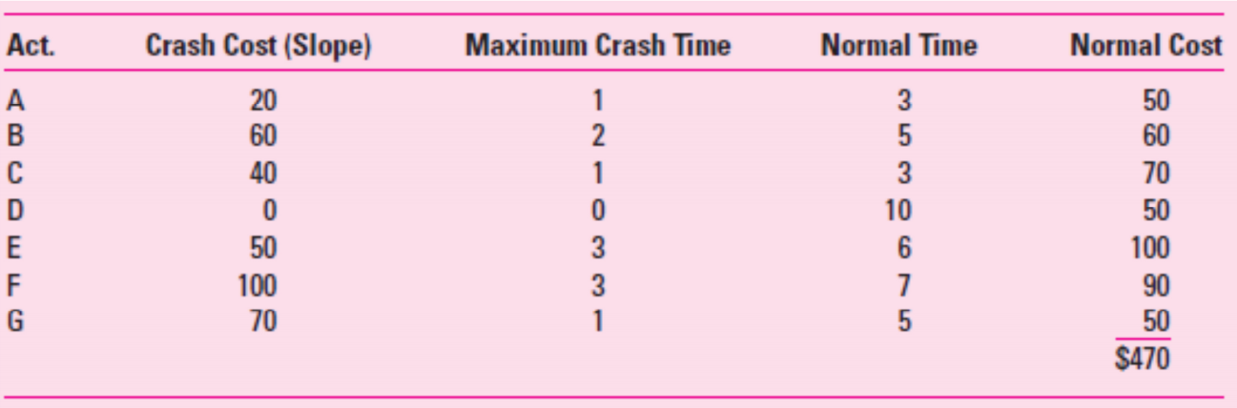

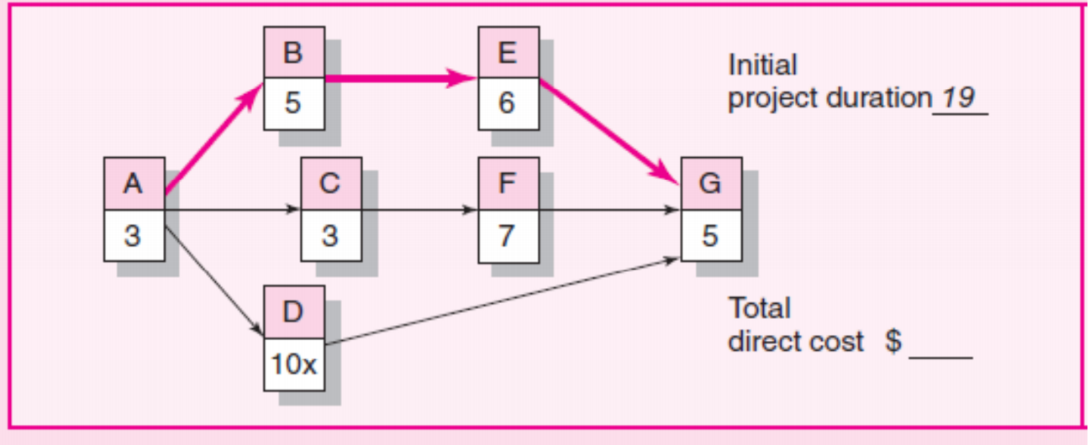

|  |  |  |  |
| --- | --- | --- | --- |
| Time Units | Direct Cost | Indirect Cost | Total Cost |
| 19 | 470 | 400 | 870 |
| 18 | 490 | 350 | 840 |
| 17 | 540 | 300 | 840 |
| 16 | 610 | 250 | 860 |

From the table, the optimum time/cost schedule is 17 time units.

## **Section B Essay Question (30 marks)**

Write a brief (800 – 1,000 words) essay on the following topic:

Why are traditional Project Management and its Methodologies less effective when running a

Greenfield Project? (10) What particular tool could be employed to improve scheduling and

budgeting? (4) Can you graphically explain it (4) and highlight the reason why (2)?

The traditional project management is typical motivated by the plan. The plan should firstly ensure the project range, feature and the source it needs. Then evaluate the required time, human resource to fit the plan. The plan should be comprehensive and including the plans like scheduling plans, communication plans, manpower allocation plans, risk plans, etc. With those plans the project can be promoted successfully. The advantage is that the risk is under controlled if the The established plan anticipated the actual situation and both the schedule and the cost can be estimated in the traditional project management.

Waterfall development model is usually used in traditional project management. The waterfall development model should be predictable in the beginning. It will be helpful in the project can not be hugely changed and little risk or error can happen in the process. The cost of changing project will be relatively a lot more than the modern project management. Because large chunks of time are spent preparing onerous documentation and there is a rigorous review process at the beginning.

Greenfield investment, also known as establishment investment or new construction investment. It refers to the enterprises in which the ownership of part or all of the assets set up by the investment subjects such as transnational corporations in accordance with the laws of the host country is owned by foreign investors.

Greenfield investment requires a lot of preparation work, so the construction cycle is long, the speed is slow and the flexibility is not enough. It has high requirements on the capital strength and operation experience of multinational companies, which is not conducive to the rapid development of multinational enterprises.

It can be seen that the value concept of traditional Project management is that the scope of requirements should be determined, preferably unchanged, which is not suitable for Greenfield Project environment. The main disadvantages are as follows;

The project process is prone to have docking problems, and the teams cannot communicate well.It is relatively difficult for the project manager to keep track of the progress of the whole project.The communication of non-critical events becomes the main problem and a lot of time will be wasted.

The event allocation of project personnel is prone to idle problems, which mainly occurs in the early and middle stage when the personnel are too idle and the arranged tasks cannot be effectively carried out in the early stage.The serious late work situation seriously affects the project schedule and quality.The situation that makes project occurrence risk increases greatly.

Weak ability to change project requirements.Once changed, the project structure changes in a series of ways.Due to its small fault tolerance rate, the probability of additional cost and time delay of the project is improved, and the project quality declines accordingly.

The related business approval process takes a long time.Due to the uncontrollable approval time, it is easy to cause the disconnection between project schedule and plan, lead to the completion time exceeding the expectation, and make the project schedule, cost and quality unbalanced.

Scurm could be employed to improve scheduling and budgeting.

It provides a team-based agile methodology, typically using an iterative development model. Agile methodology develops products in small increments after initial analysis.

Scrum introduces backlog, prioritization, iteration backlog, etc. Scrum has the advantage of being simple and easy to use, so many Internet teams are using it for reference and practice. At the same time, Scrum gathers the participation of front-line personnel, transforms small teams into independent managers through continuous experience sharing and brainstorming, constantly finds problems and prioritizes them to facilitate subsequent scheduling and repair.

Scrum starts with a rough estimate of the overall project, with a detailed plan for each iteration.It also encourages change and ensures that customer value drives development.There is a tight relationship between the customer and the developer, which promotes trust between the two.By empowering the customer, such contracts make it easy to change and add value to the project.Make risk detection earlier and more manageable.

From the above practical methods, the traditional project management method is more like the planned economy system, which pays more attention to the method and practice of planning and process control.The agile management method is more like the market economy system, more is to adapt to the environment, small steps, flexible change method practice.

One example is shown: Dutch railways are among the most used in the world, carrying 1.2m passengers a day. One department has created a new information system to provide passengers with more accurate train information and reduce human intervention. As a part of the system, PUB publishing system is needed to make centralized control of the information display and audio broadcast in all stations. Some people have tried the PUB system before, but they were using the traditional waterfall approach. The customer hands the detailed requirements document specification to the developer and then lets it sit until the full system is delivered. Three years later, the project was canceled because the developer failed to develop a working system. The client then hired us to start from scratch, using agile development and Scrum.Work closely with customers, communicate openly and take small steps forward. The project was completed in half a year.

**Section C Case Study (30 marks).**

Cerberus Project Part A

You are the assistant project manager to Kelly Brown, who is in charge of the Cerberus project.

Cerberus was the code name given to the development of a handheld electronic medical

reference guide. Cerberus would be designed for emergency medical technicians and

paramedics who need a quick reference guide to use in emergency situations.

Kelly and her project team were developing a project plan aimed at producing 30 working

models in time for MedCON, the biggest medical equipment trade show each year. Meeting the MedCON October 25th deadline is critical to success. All the major medical equipment

manufacturers demonstrated and took orders for new products at MedCON. Kelly had also

heard rumors that competitors were considering developing a similar product, and she knew that

being first to market would have a significant sales advantage. Besides, top management made

funding contingent upon developing a workable plan for meeting the MedCON deadline.

The project team spent the morning working on the schedule for Cerberus. They started with the

WBS and developed the information for a network, adding activities when needed. Then the

team added the time estimates they had collected for each activity. Following page shows the

preliminary information for activities with duration time and predecessors:

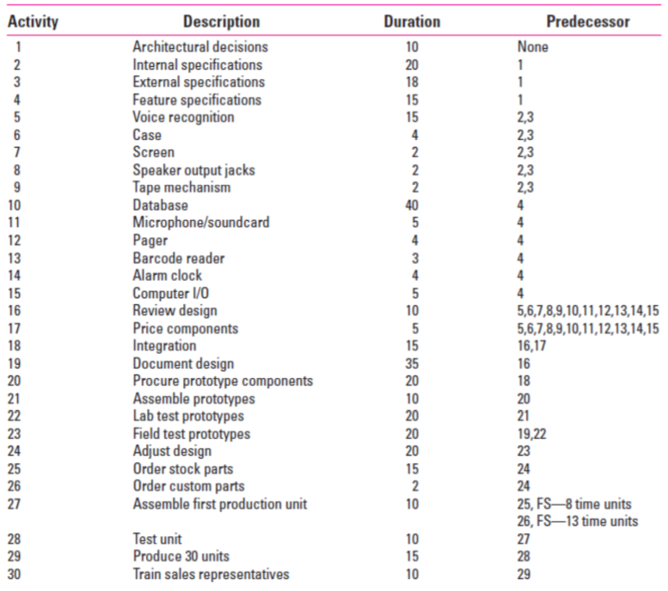

Use Project Libre to develop the schedule for activities (see Case Appendix for further

instructions)—noting late and early times, the critical path, and estimated completion for the

project.

*Save your output as Part A and use it as a baseline for Part B.*

**Cerberus Project Part B**

Kelly and the team are concerned with the results of your analysis. They spent the afternoon

brainstorming ways for shortening the project duration. They rejected outsourcing activities

because most of the work was developmental in nature and could only be done in-house.

They considered altering the scope of the project by eliminating some of the proposed product

features. After much debate, they felt they could not compromise any of the core features and

be successful in the marketplace. They then turned their attention to accelerating the completion

of activities through overtime and adding additional technical manpower. Kelly had built into

her proposal a discretionary fund of $200,000.

She was willing to invest up to half of this fund to accelerate the project, but wanted to hold

onto at least $100,000 to deal with unexpected problems. After a lengthy discussion, her team

concluded that the following activities could be reduced at the specified cost:

• Development of voice recognition system could be reduced from 15 days to 10 days at a cost

of $15,000.

• Creation of database could be reduced from 40 days to 35 days at a cost of $35,000.

• Document design could be reduced from 35 days to 30 days at a cost of $25,000.

• External specifications could be reduced from 18 days to 12 days at a cost of $20,000.

• Procure prototype components could be reduced from 20 days to 15 days at a cost of $30,000.

• Order stock parts could be reduced from 15 days to 10 days at a cost of $20,000.

Clark, a development engineer, pointed out that the network contained only finish-to-start

relationships and that it might be possible to reduce project duration by including leads and

lags. For example, he said that his people would not have to wait for all of the field tests to be

completed to begin making final adjustments in the design. They could start making

adjustments after the first 15 days of testing. The project team spent the remainder of the day

analyzing how they could introduce leads and lags into the network to hopefully shorten the

project.

They concluded that the following finish-to-start relationships could be converted into lags:

• Document design could begin 5 days after the start of the review design.

• Adjust design could begin 15 days after the start of field test prototypes.

• Order stock parts could begin 5 days after the start of adjust design.

• Order custom parts could begin 5 days after the start of adjust design.

• Training sales representatives could begin 5 days after the start of test unit and

completed 5 days after the production of 30 units.

As the meeting adjourns, Kelly turns to you and tells you to assess the options presented and try

to develop a schedule that will meet the October 25th deadline. You are to prepare a report to be

presented to the project team that addresses the following question:

**CASE APPENDIX: TECHNICAL DETAILS**

Create your project schedule and assess your options based on the following information:

1. The project will begin the first working day in January, 2019.
2. The following holidays are observed: January 1, Memorial Day (last Monday in May), July 4, Labor Day (first Monday in September), Thanksgiving Day (fourth Thursday in November), December 25 and 26.
3. If a holiday falls on a Saturday, then Friday will be given as an extra day off; if it falls on a Sunday, then Monday will be given as a day off.
4. The project team works Monday through Friday.

5. You can only spend up to $100,000 to reduce project activities; lags do not incur any additional costs.

Save your result as Project Libre File Part B and answer the following questions:

1. Comment on the final Project Plan as a Risk Manager. (7 marks)
2. Comment on the final Project Plan from a Corporate Strategy perspective. (7 marks)

3. Complete a full Project Evaluation as a Head of PMO. What is your advice for the CEO? You are not tied to any of Rachel’s previous considerations! (16 marks)

The table and the Gantt chart of part A are shown as below;

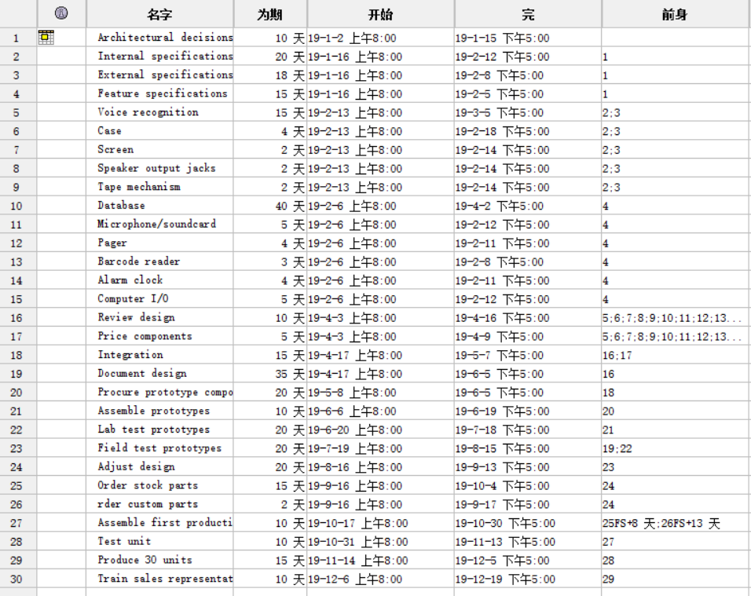

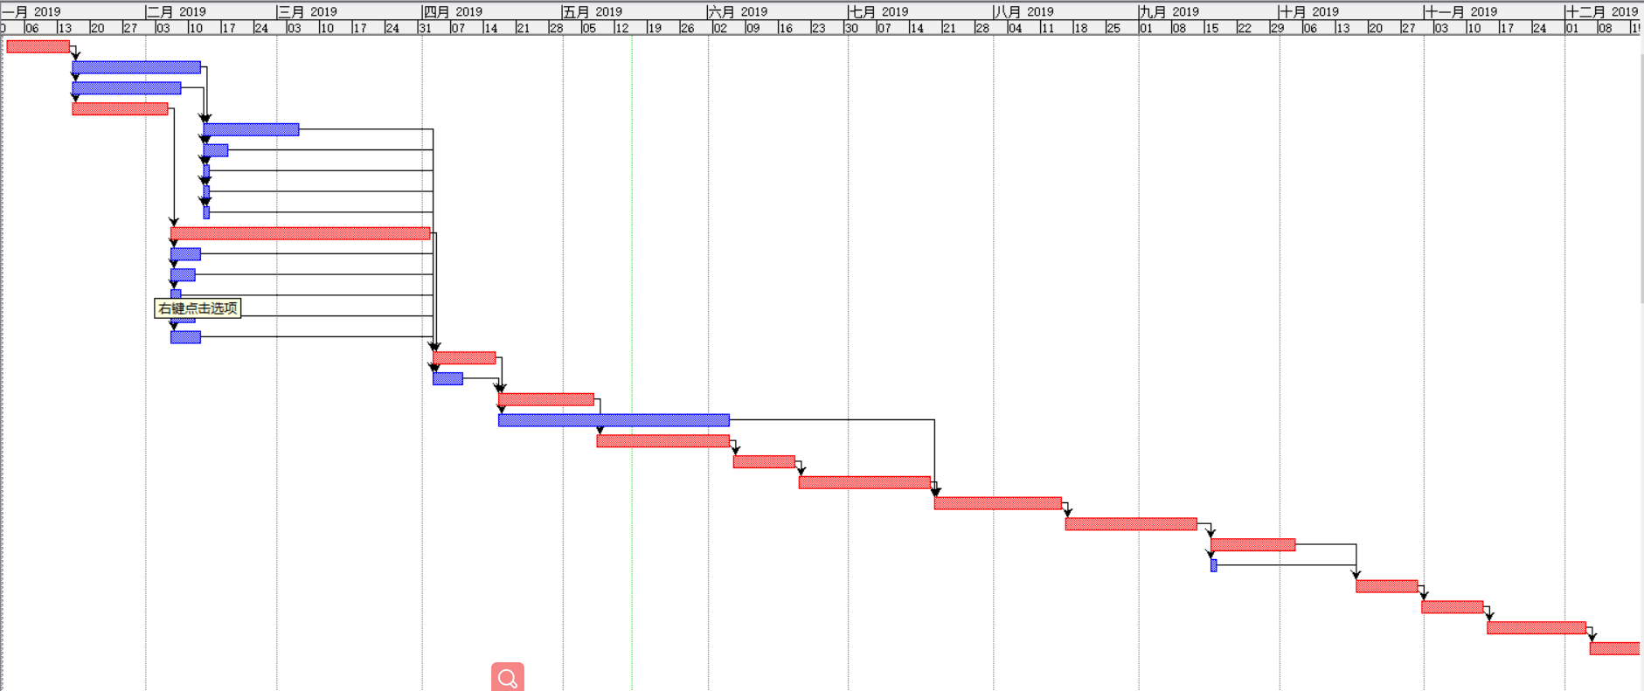

The table and the Gantt chart of part B are shown as below;

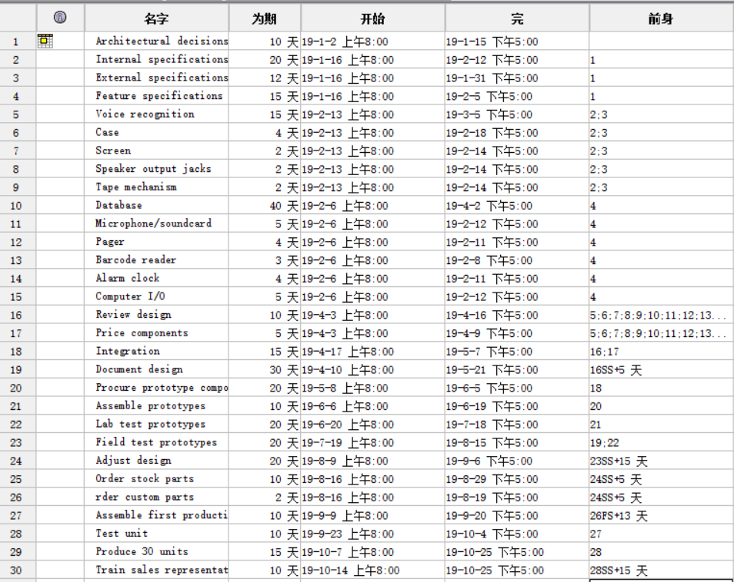

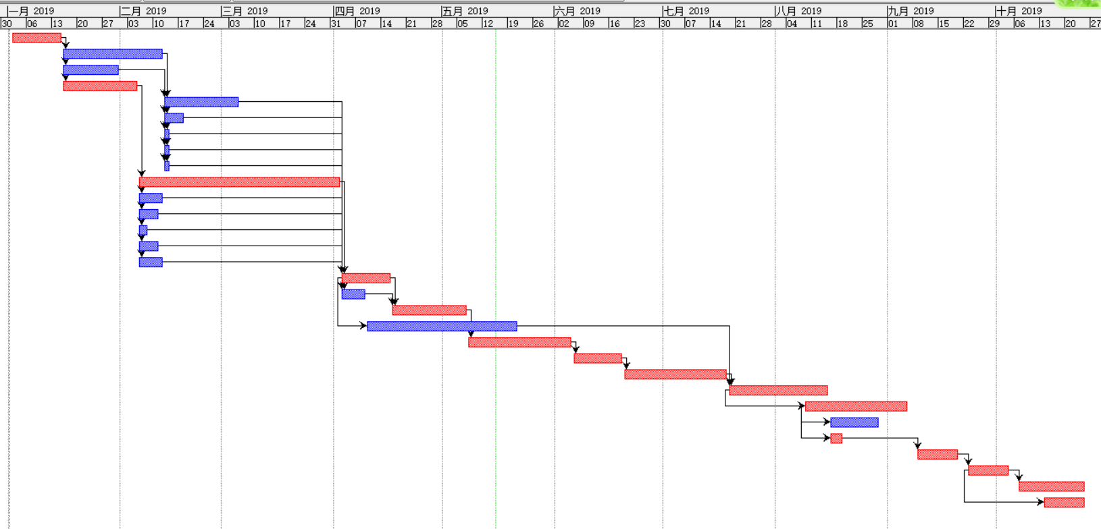

**Question 1**

In general, there are several types of situations where risks may occur;

Cost risk. Preliminary cost estimates should be made prior to the purchase of various components, such as making bom chart, not just after the purchase of all components.

Manage risk. In terms of management, the decision layer can divide the task into departments to manage the time table.After determining the starting and ending time, the department should carry out reasonable regulation and control to ensure the smooth operation of the project with stronger flexibility.

Technical risk. As the product developed in this project is a product that has never appeared in the market, it is likely to encounter some unknown problems in the development level. Therefore, it is necessary to strengthen communication with the technical department and hold more regular meetings of multiple departments and departments.

Supply risk.In terms of supply, the procurement department should also reasonably seek suitable suppliers for the proposed procurement requirements to avoid unreasonable quality, price and delivery time.

**Question 2**

As this project has a certain leading position in the medical field, it is necessary to follow up product patents as soon as possible after the completion of product design to prevent the theft of product intellectual property rights by undesirable merchants.At the same time to have a breakthrough in technology, through the development of high-level staff or extend the development time and other means to achieve technical barriers.

**Question 3**

Cost estimates should be made before parts are purchased.This schedule should be checked with each department manager in advance to see if it is beyond the department's capacity.Have the department create a schedule that matches the overall schedule.Consider whether other projects can be added synchronously while creating the database.As much as possible to consider the potential hidden dangers, such as the production of products and the actual requirements are inconsistent or design requirements too high to complete.Schedule as few projects as possible before the end of the project, leaving allocable time instead of working on multiple important projects at the end of the project.

## **Section D Project Proposal (25 marks).**

Propose a Project to XJTLU (not your group Project!) and prepare a full Proposal including Business Case and Benefit Analysis. Your document should be Boardroom ready, meaning you are comfortable giving this and presenting it to the Executive President.

**Project name:** Xipu live

**Registered capital (proposed):** 500,000 RMB

**Project brief:**

Different from the general campus platform, this product is tailored to the students of XJTLU university to create an integrated program of campus life with information matching. n the form of WeChat program, information such as offline activities and surrounding business activities that were difficult for students of XJTLU university to grasp timely and accurately were captured.

Student users can spontaneously organize and launch activities, and the published commercial information can be registered or participated online on the platform, and the promotional information can be published by themselves. It can meet the commercial needs of students' release and create a new on-campus BBS style student comment platform for activities.

Set up a relaxed and happy information matching system for the extracurricular life of XJTLU university students. Allow students to initiate extra-curricular activities including: basketball, fitness, learning, etc., can be set time, location information to find like-minded friends.Enrich the extracurricular life of students, help to expand social circle.

**Product/service introduction:**

As a WeChat small program, xipu Live is positioned as an activity-oriented matching-type social platform customized for xipu students.Moreover, it can be complementary to the official information platform (XJTLU APP).Assist the school to shorten the distance between the school, students and teachers to the greatest extent.Let students better adapt to campus life.A small program using campus resources can be upgraded to a complete version of xipu Live APP after the preliminary foundation is laid.

Xipu Live should have the following four interfaces (interface 4 is the APP promotion module of the later full version, which will not be implemented in the early stage) :

Interface 1: based on real-time map of xipu school. Students can choose to share or hide their real-time location in the map and send instant screen messages to participate in the interaction between students in the school.At the same time, I cooperated with the official information APP (XJTLU APP) of the school to set up a real-time activity chat room for the ongoing official activities in the school (entrepreneurship competition, job fair, academic lecture, BBS meeting, etc.).Display in xipu school map and show the number of participants in real time.Students can click on the title to enter the chat room and freely post comments, instant comments and feedback.

Interface 2: release list of student group activities. Students can check the information of various recent offline activities organized by students in and out of XJTLU university on xi 'an jiaotong university live, and sign up for team activities online through this platform.Team activities can also be initiated, the content of the activities can be varied. The time and place can be set freely for international students' basketball games, tennis matches, night running activities, fitness enthusiasts, team study and other spontaneous student activities.Students can also release their own personal business demand information, such as the demand for sharing, single order, second-hand goods trading demand and other legitimate needs.

Interface 3: business class information matching publication list.The products of the merchants releasing commercial information shall be the commodities closely related to the life of college students, and the merchants shall obtain the product certification after talks with the team, which can provide the maximum price discount for the students of xjtlu.Target businesses can include ielts and toefl training institutions, overseas study application agencies, catering stores around the university, KTV entertainment businesses and so on.Businesses can release activities, including discounts, group promotions, etc.All discount information should only be provided to xjtlu students.Users can view business information through this small program, or even release their own recent business needs.In the later stage, big data processing intelligent push can be achieved technically.(merchants in this interface provide alternative places and commodities for students' activities in no. 2 middle school of interface, meeting students' demand for one-stop activities)

Interface 4: display the location information of people nearby.The location information can be accurately captured according to the positioning technology. After the user turns on the positioning function, the user can view the location information of all active users within the nearby 10m, which is displayed in the form of plan or 3D map.Users can view the personal interface of nearby classmates or apply to add their friends, truly realizing the integration of real and virtual social.(considering that it is relatively difficult to implement and takes a long time to develop, this function is implemented on the APP side as a highlight)

Key technical features: indoor fixed point accurate positioning technology (by collecting and comparing the signal strength between different WIFI signals received by the user's mobile phone, the accurate location information of the user can be obtained, which solves the defects of indoor positioning of GPS positioning system in the market. The application prospect is extremely broad, and the technology reaches the international leading level.At present, this technology is owned by a professor in xipu, which has no commercial application and has the intention of teamwork.

Advantages and realizability: 1. Close cooperation with school teachers;Patents can be applied to set up technical barriers between similar social products. 2. High professional relevance fit within the team. 3. At present, similar competitive products in the market have single function, general technical content, poor real-time performance, strong replicability of the model, and fuzzy profit point. 4. On the basis of technology, it can provide more personalized functions, such as VIP value-added functions, to bring profit space for the product.

For similar products, our features are: 1. Real-time; 2. Technological; 3. Innovative; 4. Practical.

**Business model:**

Firstly, develop and operate small programs to accumulate popularity, traffic and operation experience.To achieve the goal of profit, the complete version of xipu Live APP was launched after success.As this project is highly reproducible, it can be extended to other adjacent schools and similar schools first.After that, the barriers between schools were broken down and the connection between schools was established.

**Capital budget and the use of startup capital:**

800,000 ~ 1 million RMB.Early mainly to develop small procedures.

1. The R&D cost is about 200,000 RMB.

2. The cost of publicity and marketing is about 150,000 RMB.

3. The operation and maintenance of small programs are about 50,000 yuan per month.

4. The labor cost is about 50,000 RMB per month.

**Profit model:**

1. Provide membership and other value-added services, such as paying for top headlines and special enhanced fonts.

2. Set up a business information sharing platform, provide information publishing ports for merchants, and select special offers and promotional information.Users can find their own needs in this column, can also publish their own purchase needs.

3. Publishing business information will be charged a certain fee, and reading is free.

4. Certain business commissions can be collected from merchants.

5. Split or package the business, which can be rented or sold to third parties or social companies.

**Target market share:**

1. Within six months, the coverage rate of teachers and students in xjtlu will reach 50%.
2. Achieve 70% coverage of teachers and students in xi 'an jiaotong university within one year.
3. The system will be extended to other universities in China within two to three years.

**Project implementation objectives and assessment indicators：**

Target customers: 1. Xi 'an jiaotong university student teacher (current).3. Other universities in jiangsu province (future)

Stage 1: from June to July, project approval, capital introduction, indoor positioning technology and information integration were introduced, and small program development was completed.

Stage 2: in August, the small program was put into trial operation, aiming at the preparatory students of the master language class of xi 'an jiaotong-liverpool university. The teacher went online.

Stage 3: in September, the small program was officially launched, and marketing and publicity were started. The small program was built into web celebrity product, and the focus was put on the new group, and users were started to be absorbed.

Stage 4: from October to March of the next year: basically reach the planned market share of users, basically achieve the balance of income and expenditure, and improve functions and services.

Stage 5: from April to June of the next year, complete the development of supporting app and launch the app, integrate the people search function in the vicinity based on precise positioning technology into the data of small program, and drain small program customers to the app.

Stage 6: from July to August of the next year, small programs and apps will be packaged and promoted to all colleges and universities in dushu lake higher education area and domestic and foreign cooperative universities, so as to form unique small programs and apps in each school according to the characteristics of each school.

Stage 7: from September to December of the next year, the adjacent school circles will be opened up to form a common social app between schools, and prepare for the later infiltration into other cities in jiangsu province besides suzhou.

**-----END OF PAPER-----**